- Salary Analysis Using Subqueries
--1: Employees earning MORE than the company AVERAGE salary
SELECT EMPLOYEE_ID,
FIRST_NAME || ' ' || LAST_NAME AS Full_Name,
JOB_ID,
SALARY,
ROUND((SELECT AVG(SALARY)
FROM EMPLOYEES), 2) AS Company_Avg,
ROUND(SALARY -
(SELECT AVG(SALARY)
FROM EMPLOYEES), 2) AS Above_Avg_By
FROM EMPLOYEES
WHERE SALARY > (SELECT AVG(SALARY)
FROM EMPLOYEES)
ORDER BY SALARY DESC;

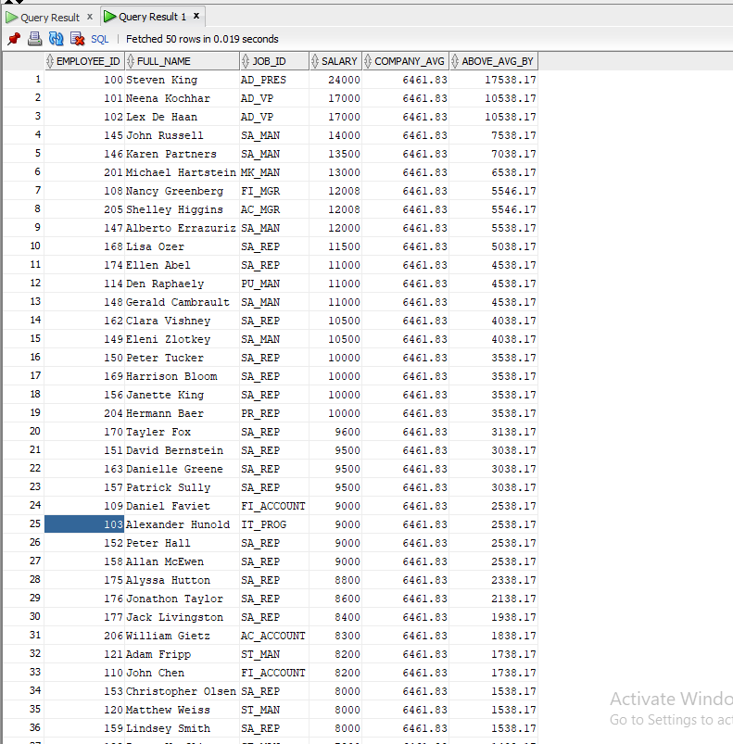

- Employees earning less than highest salary
SELECT EMPLOYEE_ID,
FIRST_NAME || ' ' || LAST_NAME AS Full_Name,
JOB_ID,
SALARY,
(SELECT MAX(SALARY)
FROM EMPLOYEES) AS Max_Salary,
(SELECT MAX(SALARY)
FROM EMPLOYEES) - SALARY AS Below_Max_By
FROM EMPLOYEES
WHERE SALARY < (SELECT MAX(SALARY)
FROM EMPLOYEES)
ORDER BY SALARY DESC;
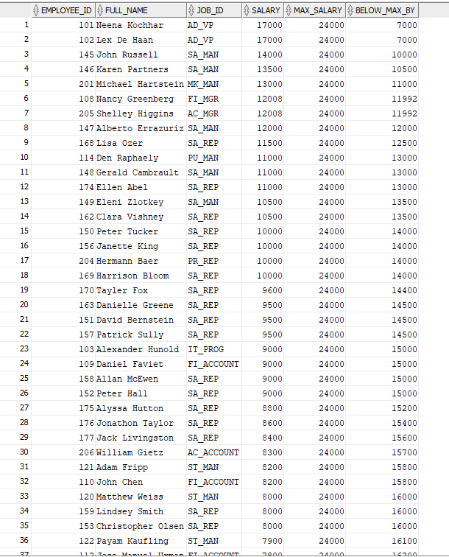

--3: Departments whose average salary exceeds the company average salary.
SELECT D.DEPARTMENT_ID,
D.DEPARTMENT_NAME,
COUNT(E.EMPLOYEE_ID) AS Total_Employees,
ROUND(AVG(E.SALARY), 2) AS Dept_Avg_Salary,
ROUND((SELECT AVG(SALARY)
FROM EMPLOYEES), 2) AS Company_Avg_Salary,
ROUND(AVG(E.SALARY) -
(SELECT AVG(SALARY)
FROM EMPLOYEES), 2) AS Exceeds_By
FROM EMPLOYEES E
JOIN DEPARTMENTS D ON E.DEPARTMENT_ID = D.DEPARTMENT_ID
GROUP BY D.DEPARTMENT_ID,
D.DEPARTMENT_NAME
HAVING AVG(E.SALARY) > (SELECT AVG(SALARY)
FROM EMPLOYEES)
ORDER BY Dept_Avg_Salary DESC;
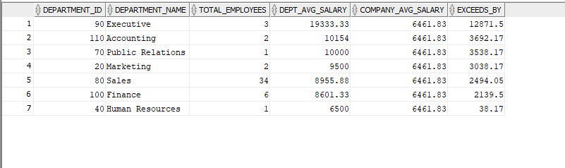

--4. Employees earning the highest salary within their department.
SELECT E.EMPLOYEE_ID,
E.FIRST_NAME || ' ' || E.LAST_NAME AS Full_Name,
E.JOB_ID,
E.SALARY AS Highest_Salary,
E.DEPARTMENT_ID,
D.DEPARTMENT_NAME,
(SELECT COUNT(*)
FROM EMPLOYEES E3
WHERE E3.DEPARTMENT_ID
= E.DEPARTMENT_ID) AS Dept_Total_Emp,
ROUND((SELECT AVG(E2.SALARY)
FROM EMPLOYEES E2
WHERE E2.DEPARTMENT_ID
= E.DEPARTMENT_ID), 2) AS Dept_Avg_Salary
FROM EMPLOYEES E
JOIN DEPARTMENTS D ON E.DEPARTMENT_ID = D.DEPARTMENT_ID
WHERE E.SALARY = (SELECT MAX(E2.SALARY)
FROM EMPLOYEES E2
WHERE E2.DEPARTMENT_ID
= E.DEPARTMENT_ID)
ORDER BY E.SALARY DESC;

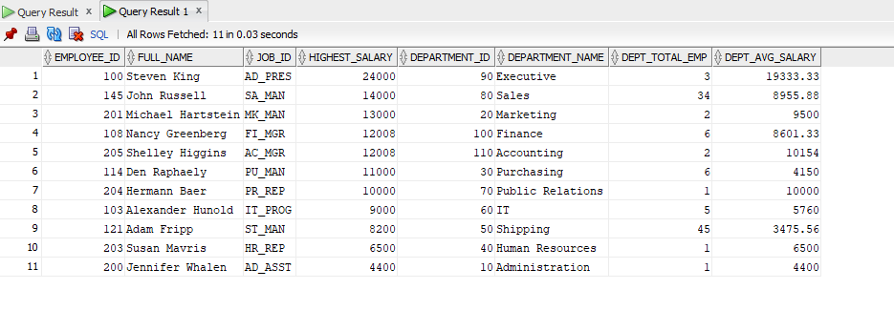

2. Department & Location Analysis
Using subqueries (avoiding JOINs where required), create reports for:

1. Employees working in departments located in the United States.
SELECT EMPLOYEE_ID,
FIRST_NAME || ' ' || LAST_NAME AS Full_Name,
JOB_ID,
SALARY,
DEPARTMENT_ID
FROM EMPLOYEES
WHERE DEPARTMENT_ID IN
(SELECT DEPARTMENT_ID
FROM DEPARTMENTS
WHERE LOCATION_ID IN
(SELECT LOCATION_ID
FROM LOCATIONS
WHERE COUNTRY_ID IN
(SELECT COUNTRY_ID
FROM COUNTRIES
WHERE COUNTRY_NAME
= 'United States of America')))
ORDER BY DEPARTMENT_ID,
SALARY DESC;
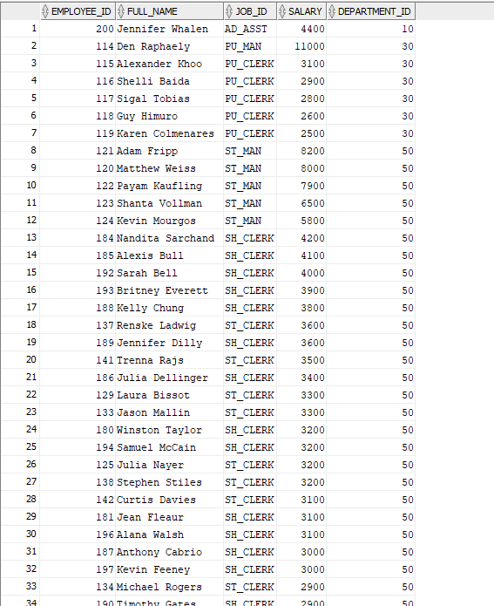

2.Departments that currently contain employees.
SELECT DEPARTMENT_ID,
DEPARTMENT_NAME,
MANAGER_ID,
LOCATION_ID
FROM DEPARTMENTS D
WHERE EXISTS
(SELECT 1
FROM EMPLOYEES E
WHERE E.DEPARTMENT_ID
= D.DEPARTMENT_ID)
ORDER BY DEPARTMENT_ID;
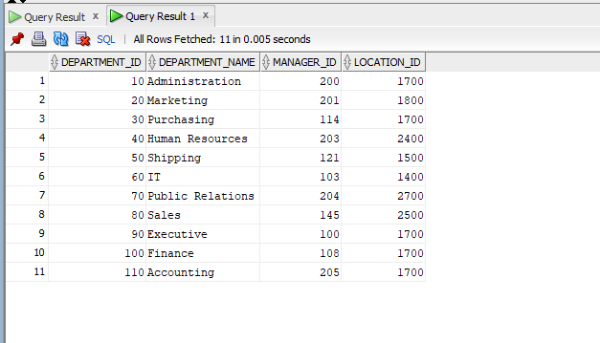

- Departments that currently have no employees.
SELECT DEPARTMENT_ID,
DEPARTMENT_NAME,
MANAGER_ID,
LOCATION_ID
FROM DEPARTMENTS D
WHERE NOT EXISTS
(SELECT 1
FROM EMPLOYEES E
WHERE E.DEPARTMENT_ID
= D.DEPARTMENT_ID)
ORDER BY DEPARTMENT_ID;
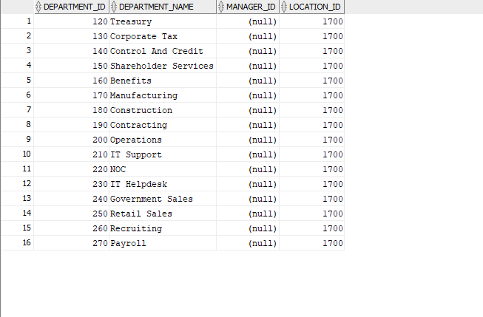

- Employees working in departments located in the Europe region using nested subqueries.
SELECT EMPLOYEE_ID,
FIRST_NAME || ' ' || LAST_NAME AS Full_Name,
JOB_ID,
SALARY,
DEPARTMENT_ID,
(SELECT DEPARTMENT_NAME
FROM DEPARTMENTS
WHERE DEPARTMENT_ID
= E.DEPARTMENT_ID) AS Department_Name,
(SELECT COUNTRY_NAME
FROM COUNTRIES
WHERE COUNTRY_ID =
(SELECT COUNTRY_ID
FROM LOCATIONS
WHERE LOCATION_ID =
(SELECT LOCATION_ID
FROM DEPARTMENTS
WHERE DEPARTMENT_ID
= E.DEPARTMENT_ID))) AS Country_Name
FROM EMPLOYEES E
WHERE DEPARTMENT_ID IN
(SELECT DEPARTMENT_ID
FROM DEPARTMENTS
WHERE LOCATION_ID IN
(SELECT LOCATION_ID
FROM LOCATIONS
WHERE COUNTRY_ID IN
(SELECT COUNTRY_ID
FROM COUNTRIES
WHERE REGION_ID =
(SELECT REGION_ID
FROM REGIONS
WHERE REGION_NAME
= 'Europe'))))
ORDER BY DEPARTMENT_ID,
SALARY DESC;
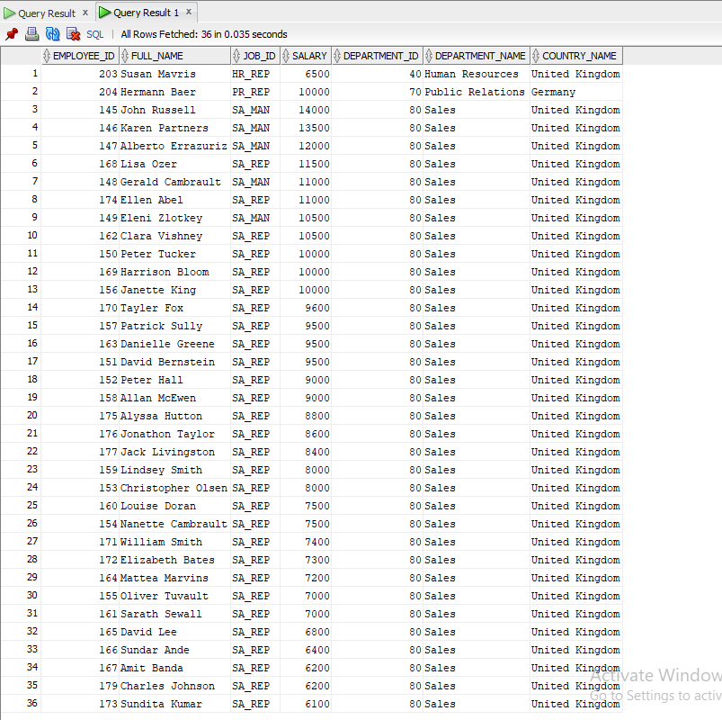

3. Manager & Hierarchy Analysis
1. Employees earning more than their manager.
SELECT E.EMPLOYEE_ID, E.FIRST_NAME || ' ' || E.LAST_NAME AS Employee_Name, E.JOB_ID AS Employee_Job, E.DEPARTMENT_ID, E.SALARY AS Employee_Salary, (SELECT FIRST_NAME || ' ' || LAST_NAME FROM EMPLOYEES WHERE EMPLOYEE_ID = E.MANAGER_ID) AS Manager_Name, (SELECT SALARY FROM EMPLOYEES WHERE EMPLOYEE_ID = E.MANAGER_ID) AS Manager_Salary, E.SALARY - (SELECT SALARY FROM EMPLOYEES WHERE EMPLOYEE_ID = E.MANAGER_ID) AS Salary_Difference FROM EMPLOYEES E WHERE E.SALARY > (SELECT SALARY FROM EMPLOYEES WHERE EMPLOYEE_ID = E.MANAGER_ID) ORDER BY Salary_Difference DESC;
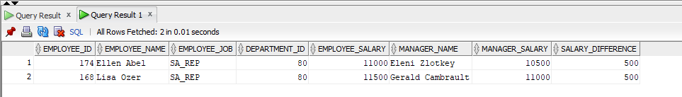
2. Managers supervising at least one employee earning more than 10,000.

SELECT EMPLOYEE_ID, FIRST_NAME || ' ' || LAST_NAME AS Manager_Name, JOB_ID, DEPARTMENT_ID, SALARY AS Manager_Salary, (SELECT COUNT(*) FROM EMPLOYEES E WHERE E.MANAGER_ID = M.EMPLOYEE_ID AND E.SALARY > 10000) AS High_Earners_Count, (SELECT MAX(SALARY) FROM EMPLOYEES E WHERE E.MANAGER_ID = M.EMPLOYEE_ID AND E.SALARY > 10000) AS Highest_Sub_Salary FROM EMPLOYEES M WHERE EXISTS (SELECT 1 FROM EMPLOYEES E WHERE E.MANAGER_ID = M.EMPLOYEE_ID AND E.SALARY > 10000) ORDER BY High_Earners_Count DESC, Manager_Salary DESC;
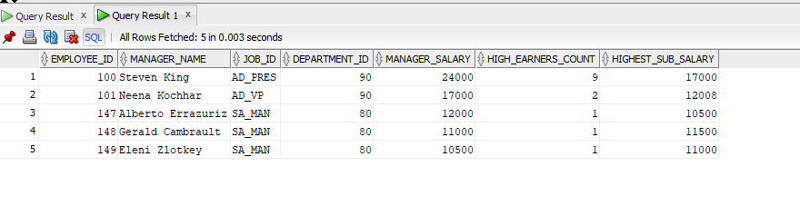
3. Employees whose manager works in the same department.
SELECT E.EMPLOYEE_ID, E.FIRST_NAME || ' ' || E.LAST_NAME AS Employee_Name, E.JOB_ID AS Employee_Job, E.SALARY AS Employee_Salary, E.DEPARTMENT_ID, (SELECT DEPARTMENT_NAME FROM DEPARTMENTS WHERE DEPARTMENT_ID = E.DEPARTMENT_ID) AS Department_Name, (SELECT FIRST_NAME || ' ' || LAST_NAME FROM EMPLOYEES WHERE EMPLOYEE_ID = E.MANAGER_ID) AS Manager_Name, (SELECT DEPARTMENT_ID FROM EMPLOYEES WHERE EMPLOYEE_ID = E.MANAGER_ID) AS Manager_Dept_ID FROM EMPLOYEES E WHERE E.MANAGER_ID IS NOT NULL AND E.DEPARTMENT_ID = (SELECT DEPARTMENT_ID FROM EMPLOYEES WHERE EMPLOYEE_ID = E.MANAGER_ID) ORDER BY E.DEPARTMENT_ID, E.SALARY DESC;
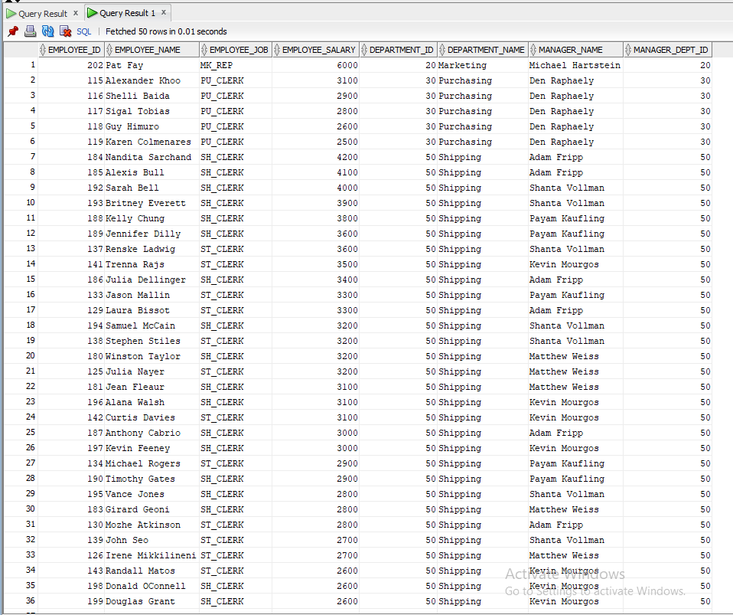

4.Employees whose manager works in a different department.
SELECT E.EMPLOYEE_ID,
E.FIRST_NAME || ' ' || E.LAST_NAME AS Employee_Name,
E.JOB_ID AS Employee_Job,
E.SALARY AS Employee_Salary,
E.DEPARTMENT_ID AS Employee_Dept_ID,
(SELECT DEPARTMENT_NAME
FROM DEPARTMENTS
WHERE DEPARTMENT_ID
= E.DEPARTMENT_ID) AS Employee_Dept_Name,
(SELECT FIRST_NAME || ' ' || LAST_NAME
FROM EMPLOYEES
WHERE EMPLOYEE_ID
= E.MANAGER_ID) AS Manager_Name,
(SELECT DEPARTMENT_ID
FROM EMPLOYEES
WHERE EMPLOYEE_ID
= E.MANAGER_ID) AS Manager_Dept_ID,
(SELECT DEPARTMENT_NAME
FROM DEPARTMENTS
WHERE DEPARTMENT_ID =
(SELECT DEPARTMENT_ID
FROM EMPLOYEES
WHERE EMPLOYEE_ID
= E.MANAGER_ID)) AS Manager_Dept_Name
FROM EMPLOYEES E
WHERE E.MANAGER_ID IS NOT NULL
AND E.DEPARTMENT_ID <>
(SELECT DEPARTMENT_ID
FROM EMPLOYEES
WHERE EMPLOYEE_ID
= E.MANAGER_ID)
ORDER BY E.DEPARTMENT_ID,
E.SALARY DESC;
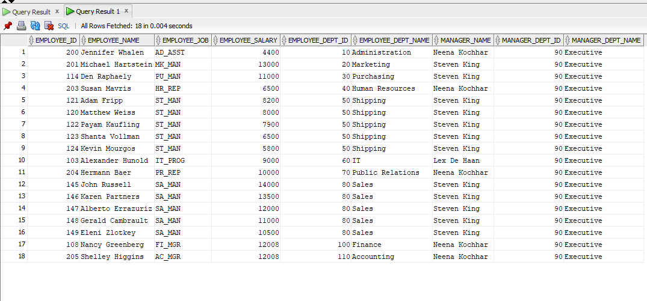
4. Inline View & Query Execution
Build inline view solutions for:
- Filtering employees earning more than 10,000.
SELECT EMP_VIEW.EMPLOYEE_ID, EMP_VIEW.Full_Name, EMP_VIEW.JOB_ID, EMP_VIEW.DEPARTMENT_ID, EMP_VIEW.SALARY, EMP_VIEW.HIRE_DATE, EMP_VIEW.Salary_Category FROM (SELECT E.EMPLOYEE_ID, E.FIRST_NAME || ' ' || E.LAST_NAME AS Full_Name, E.JOB_ID, E.DEPARTMENT_ID, E.SALARY, E.HIRE_DATE, CASE WHEN E.SALARY >= 20000 THEN 'Very High (20000+)' WHEN E.SALARY >= 15000 THEN 'High (15000-19999)' WHEN E.SALARY >= 10000 THEN 'Above 10000' ELSE 'Below 10000' END AS Salary_Category FROM EMPLOYEES E) EMP_VIEW WHERE EMP_VIEW.SALARY > 10000 ORDER BY EMP_VIEW.SALARY DESC;
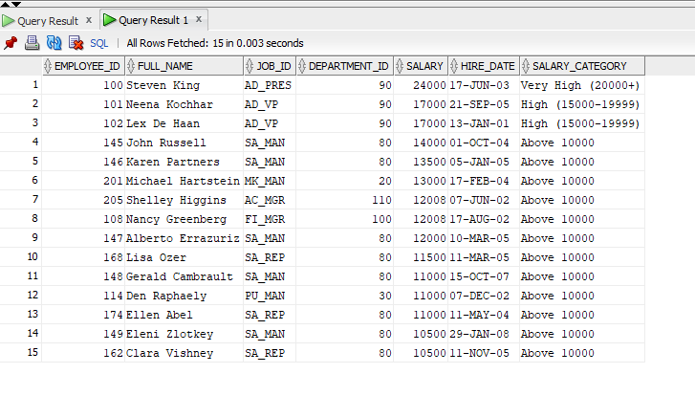
2.Displaying departments with average salary greater than 9,000.
SELECT DEPT_VIEW.DEPARTMENT_ID, DEPT_VIEW.DEPARTMENT_NAME, DEPT_VIEW.Total_Employees, DEPT_VIEW.Avg_Salary, DEPT_VIEW.Max_Salary, DEPT_VIEW.Min_Salary, DEPT_VIEW.Total_Salary, ROUND(DEPT_VIEW.Avg_Salary - (SELECT AVG(SALARY) FROM EMPLOYEES), 2) AS Above_Company_Avg FROM (SELECT D.DEPARTMENT_ID, D.DEPARTMENT_NAME, COUNT(E.EMPLOYEE_ID) AS Total_Employees, ROUND(AVG(E.SALARY), 2) AS Avg_Salary, MAX(E.SALARY) AS Max_Salary, MIN(E.SALARY) AS Min_Salary, SUM(E.SALARY) AS Total_Salary FROM EMPLOYEES E JOIN DEPARTMENTS D ON E.DEPARTMENT_ID = D.DEPARTMENT_ID GROUP BY D.DEPARTMENT_ID, D.DEPARTMENT_NAME) DEPT_VIEW WHERE DEPT_VIEW.Avg_Salary > 9000 ORDER BY DEPT_VIEW.Avg_Salary DESC;
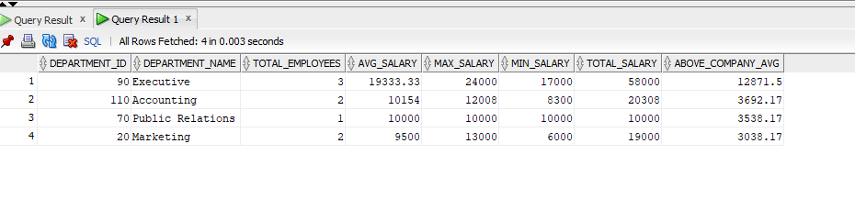
3. 3.Displaying departments with more than five employees.
SELECT DEPT_COUNT_VIEW.DEPARTMENT_ID,
DEPT_COUNT_VIEW.DEPARTMENT_NAME,
DEPT_COUNT_VIEW.Total_Employees,
DEPT_COUNT_VIEW.Avg_Salary,
DEPT_COUNT_VIEW.Max_Salary,
DEPT_COUNT_VIEW.Min_Salary,
DEPT_COUNT_VIEW.Total_Salary,
DEPT_COUNT_VIEW.Salary_Rank
FROM
(SELECT D.DEPARTMENT_ID,
D.DEPARTMENT_NAME,
COUNT(E.EMPLOYEE_ID) AS Total_Employees,
ROUND(AVG(E.SALARY), 2) AS Avg_Salary,
MAX(E.SALARY) AS Max_Salary,
MIN(E.SALARY) AS Min_Salary,
SUM(E.SALARY) AS Total_Salary,
RANK() OVER
(ORDER BY COUNT(E.EMPLOYEE_ID)
DESC) AS Salary_Rank
FROM EMPLOYEES E
JOIN DEPARTMENTS D ON E.DEPARTMENT_ID
= D.DEPARTMENT_ID
GROUP BY D.DEPARTMENT_ID,
D.DEPARTMENT_NAME) DEPT_COUNT_VIEW
WHERE DEPT_COUNT_VIEW.Total_Employees > 5
ORDER BY DEPT_COUNT_VIEW.Total_Employees DESC;
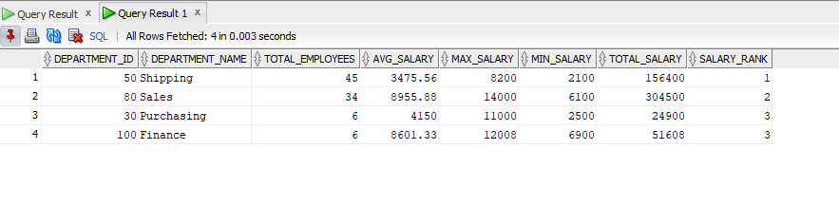

- Advanced Subquery Logic
- Employees earning above their department average salary.
SELECT E.EMPLOYEE_ID,
E.FIRST_NAME || ' ' || E.LAST_NAME AS Full_Name,
E.JOB_ID,
E.DEPARTMENT_ID,
(SELECT DEPARTMENT_NAME
FROM DEPARTMENTS
WHERE DEPARTMENT_ID
= E.DEPARTMENT_ID) AS Department_Name,
E.SALARY AS Employee_Salary,
ROUND((SELECT AVG(E2.SALARY)
FROM EMPLOYEES E2
WHERE E2.DEPARTMENT_ID
= E.DEPARTMENT_ID), 2) AS Dept_Avg_Salary,
ROUND(E.SALARY -
(SELECT AVG(E2.SALARY)
FROM EMPLOYEES E2
WHERE E2.DEPARTMENT_ID
= E.DEPARTMENT_ID), 2) AS Above_Dept_Avg_By,
ROUND((E.SALARY -
(SELECT AVG(E2.SALARY)
FROM EMPLOYEES E2
WHERE E2.DEPARTMENT_ID
= E.DEPARTMENT_ID)) /
(SELECT AVG(E2.SALARY)
FROM EMPLOYEES E2
WHERE E2.DEPARTMENT_ID
= E.DEPARTMENT_ID) * 100,
2) AS Pct_Above_Avg
FROM EMPLOYEES E
WHERE E.SALARY >
(SELECT AVG(E2.SALARY)
FROM EMPLOYEES E2
WHERE E2.DEPARTMENT_ID
= E.DEPARTMENT_ID)
ORDER BY E.DEPARTMENT_ID,
E.SALARY DESC;
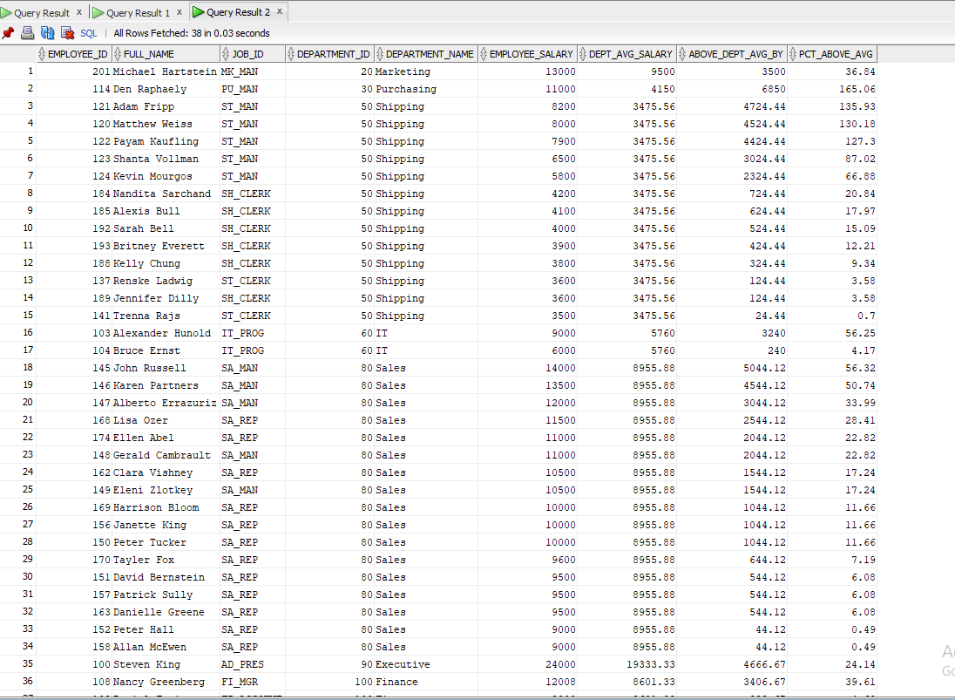

- Employees earning above the average salary for their job role.
SELECT E.EMPLOYEE_ID,
E.FIRST_NAME || ' ' || E.LAST_NAME AS Full_Name,
E.JOB_ID,
(SELECT J.JOB_TITLE
FROM JOBS J
WHERE J.JOB_ID
= E.JOB_ID) AS Job_Title,
E.DEPARTMENT_ID,
E.SALARY AS Employee_Salary,
ROUND((SELECT AVG(E2.SALARY)
FROM EMPLOYEES E2
WHERE E2.JOB_ID
= E.JOB_ID), 2) AS Job_Avg_Salary,
ROUND(E.SALARY -
(SELECT AVG(E2.SALARY)
FROM EMPLOYEES E2
WHERE E2.JOB_ID
= E.JOB_ID), 2) AS Above_Job_Avg_By,
(SELECT J.MAX_SALARY
FROM JOBS J
WHERE J.JOB_ID
= E.JOB_ID) AS Job_Max_Salary,
(SELECT J.MIN_SALARY
FROM JOBS J
WHERE J.JOB_ID
= E.JOB_ID) AS Job_Min_Salary
FROM EMPLOYEES E
WHERE E.SALARY >
(SELECT AVG(E2.SALARY)
FROM EMPLOYEES E2
WHERE E2.JOB_ID
= E.JOB_ID)
ORDER BY E.JOB_ID,
E.SALARY DESC;
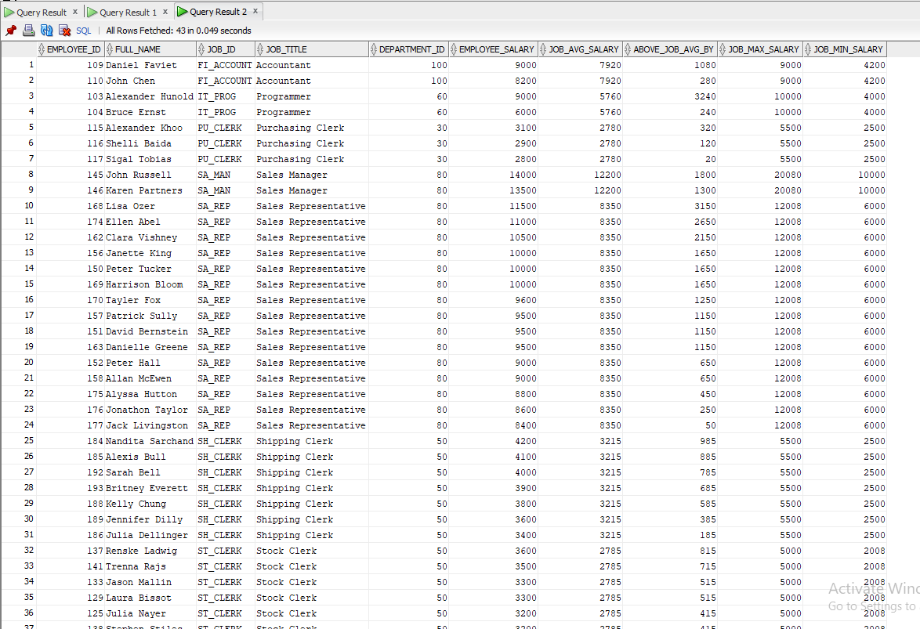

- Departments where all employees earn more than 5,000.
SELECT D.DEPARTMENT_ID,
D.DEPARTMENT_NAME,
(SELECT COUNT(*)
FROM EMPLOYEES E
WHERE E.DEPARTMENT_ID
= D.DEPARTMENT_ID) AS Total_Employees,
(SELECT MIN(E.SALARY)
FROM EMPLOYEES E
WHERE E.DEPARTMENT_ID
= D.DEPARTMENT_ID) AS Min_Salary,
(SELECT MAX(E.SALARY)
FROM EMPLOYEES E
WHERE E.DEPARTMENT_ID
= D.DEPARTMENT_ID) AS Max_Salary,
(SELECT ROUND(AVG(E.SALARY), 2)
FROM EMPLOYEES E
WHERE E.DEPARTMENT_ID
= D.DEPARTMENT_ID) AS Avg_Salary
FROM DEPARTMENTS D
WHERE EXISTS
(SELECT 1
FROM EMPLOYEES E
WHERE E.DEPARTMENT_ID
= D.DEPARTMENT_ID)
AND NOT EXISTS
(SELECT 1
FROM EMPLOYEES E
WHERE E.DEPARTMENT_ID
= D.DEPARTMENT_ID
AND E.SALARY <= 5000)
ORDER BY D.DEPARTMENT_ID;
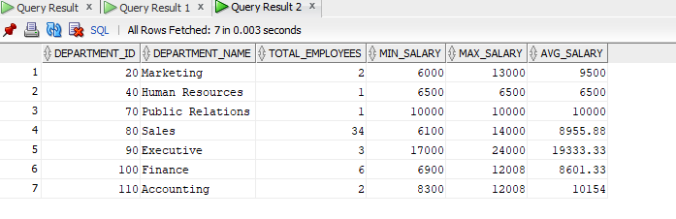

4. Employees who are the only employee in their department.
SELECT E.EMPLOYEE_ID,
E.FIRST_NAME || ' ' || E.LAST_NAME AS Full_Name,
E.JOB_ID,
E.SALARY,
E.HIRE_DATE,
E.DEPARTMENT_ID,
(SELECT DEPARTMENT_NAME
FROM DEPARTMENTS
WHERE DEPARTMENT_ID
= E.DEPARTMENT_ID) AS Department_Name,
(SELECT COUNT(*)
FROM EMPLOYEES E2
WHERE E2.DEPARTMENT_ID
= E.DEPARTMENT_ID) AS Dept_Employee_Count
FROM EMPLOYEES E
WHERE 1 =
(SELECT COUNT(*)
FROM EMPLOYEES E2
WHERE E2.DEPARTMENT_ID
= E.DEPARTMENT_ID)
ORDER BY E.DEPARTMENT_ID;
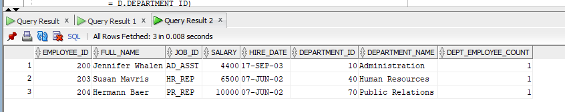

6. Executive HR Analytics Challenge
Develop analytical reports using subqueries for:
1. Employees earning above the company average salary.
SELECT E.EMPLOYEE_ID,
E.FIRST_NAME || ' ' || E.LAST_NAME AS Full_Name,
E.JOB_ID,
E.DEPARTMENT_ID,
(SELECT DEPARTMENT_NAME
FROM DEPARTMENTS
WHERE DEPARTMENT_ID
= E.DEPARTMENT_ID) AS Department_Name,
E.SALARY AS Employee_Salary,
ROUND((SELECT AVG(SALARY)
FROM EMPLOYEES), 2) AS Company_Avg,
ROUND(E.SALARY -
(SELECT AVG(SALARY)
FROM EMPLOYEES), 2) AS Above_Avg_By,
ROUND((E.SALARY -
(SELECT AVG(SALARY)
FROM EMPLOYEES)) /
(SELECT AVG(SALARY)
FROM EMPLOYEES) * 100,
2) AS Pct_Above_Avg
FROM EMPLOYEES E
WHERE E.SALARY >
(SELECT AVG(SALARY)
FROM EMPLOYEES)
ORDER BY E.SALARY DESC;
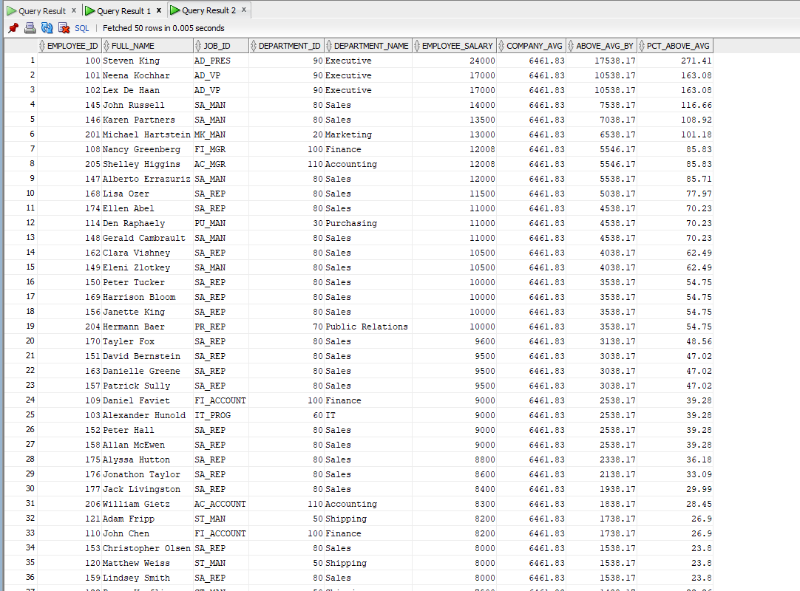

--2.Departments with more employees than Department 50.
SELECT D.DEPARTMENT_ID,
D.DEPARTMENT_NAME,
(SELECT COUNT(*)
FROM EMPLOYEES E
WHERE E.DEPARTMENT_ID
= D.DEPARTMENT_ID) AS Total_Employees,
(SELECT COUNT(*)
FROM EMPLOYEES
WHERE DEPARTMENT_ID = 50) AS Dept50_Count,
(SELECT COUNT(*)
FROM EMPLOYEES E
WHERE E.DEPARTMENT_ID
= D.DEPARTMENT_ID) -
(SELECT COUNT(*)
FROM EMPLOYEES
WHERE DEPARTMENT_ID = 50) AS Difference,
(SELECT ROUND(AVG(SALARY), 2)
FROM EMPLOYEES E
WHERE E.DEPARTMENT_ID
= D.DEPARTMENT_ID) AS Dept_Avg_Salary
FROM DEPARTMENTS D
WHERE (SELECT COUNT(*)
FROM EMPLOYEES E
WHERE E.DEPARTMENT_ID
= D.DEPARTMENT_ID) >
(SELECT COUNT(*)
FROM EMPLOYEES
WHERE DEPARTMENT_ID = 50)
ORDER BY Total_Employees DESC;

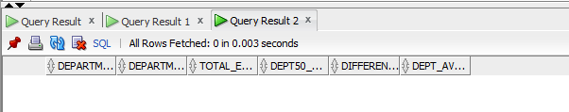

3. Employees earning the second-highest salary.
SELECT E.EMPLOYEE_ID,
E.FIRST_NAME || ' ' || E.LAST_NAME AS Full_Name,
E.JOB_ID,
E.SALARY,
E.DEPARTMENT_ID,
(SELECT DEPARTMENT_NAME
FROM DEPARTMENTS
WHERE DEPARTMENT_ID
= E.DEPARTMENT_ID) AS Department_Name,
(SELECT ROUND(AVG(E2.SALARY), 2)
FROM EMPLOYEES E2
WHERE E2.DEPARTMENT_ID
= E.DEPARTMENT_ID) AS Dept_Avg_Salary,
(SELECT ROUND(MAX(Dept_Avg), 2)
FROM (SELECT AVG(SALARY) AS Dept_Avg
FROM EMPLOYEES
GROUP BY DEPARTMENT_ID)) AS Highest_Dept_Avg
FROM EMPLOYEES E
WHERE E.DEPARTMENT_ID =
(SELECT DEPARTMENT_ID
FROM
(SELECT DEPARTMENT_ID,
AVG(SALARY) AS Avg_Sal
FROM EMPLOYEES
GROUP BY DEPARTMENT_ID
ORDER BY Avg_Sal DESC)
WHERE ROWNUM = 1)
ORDER BY E.SALARY DESC;
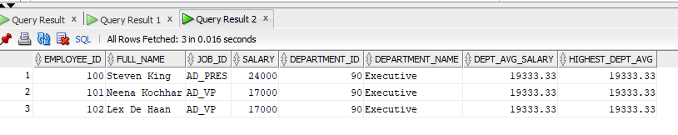

4.Employees earning the second-highest salary.
SELECT E.EMPLOYEE_ID,
E.FIRST_NAME || ' ' || E.LAST_NAME AS Full_Name,
E.JOB_ID,
E.DEPARTMENT_ID,
(SELECT DEPARTMENT_NAME
FROM DEPARTMENTS
WHERE DEPARTMENT_ID = E.DEPARTMENT_ID) AS Department_Name,
E.SALARY AS Second_Highest_Salary,
(SELECT MAX(SALARY) FROM EMPLOYEES) AS Highest_Salary,
(SELECT MAX(SALARY) FROM EMPLOYEES)
- E.SALARY AS Below_Highest_By
FROM EMPLOYEES E
WHERE E.SALARY = (SELECT MAX(SALARY)
FROM EMPLOYEES
WHERE SALARY < (SELECT MAX(SALARY)
FROM EMPLOYEES))
ORDER BY E.EMPLOYEE_ID;

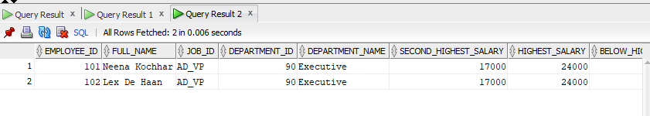

5.Managers whose employees' average salary exceeds 10,000.
SELECT M.EMPLOYEE_ID AS Manager_ID,
M.FIRST_NAME || ' ' || M.LAST_NAME AS Manager_Name,
M.JOB_ID AS Manager_Job,
M.SALARY AS Manager_Salary,
M.DEPARTMENT_ID,
(SELECT DEPARTMENT_NAME
FROM DEPARTMENTS
WHERE DEPARTMENT_ID
= M.DEPARTMENT_ID) AS Department_Name,
(SELECT COUNT(*)
FROM EMPLOYEES E
WHERE E.MANAGER_ID
= M.EMPLOYEE_ID) AS Total_Subordinates,
ROUND((SELECT AVG(E.SALARY)
FROM EMPLOYEES E
WHERE E.MANAGER_ID
= M.EMPLOYEE_ID), 2) AS Subordinates_Avg_Sal,
(SELECT MAX(E.SALARY)
FROM EMPLOYEES E
WHERE E.MANAGER_ID
= M.EMPLOYEE_ID) AS Subordinates_Max_Sal,
(SELECT MIN(E.SALARY)
FROM EMPLOYEES E
WHERE E.MANAGER_ID
= M.EMPLOYEE_ID) AS Subordinates_Min_Sal
FROM EMPLOYEES M
WHERE EXISTS
(SELECT 1
FROM EMPLOYEES E
WHERE E.MANAGER_ID
= M.EMPLOYEE_ID)
AND (SELECT AVG(E.SALARY)
FROM EMPLOYEES E
WHERE E.MANAGER_ID
= M.EMPLOYEE_ID) > 10000
ORDER BY Subordinates_Avg_Sal DESC;

